**REST - Get all countries** 

**Country.xml:**

<beans xmlns="http://www.springframework.org/schema/beans"

xmlns:xsi="http://www.w3.org/2001/XMLSchema-instance"

xsi:schemaLocation="http://www.springframework.org/schema/beans

http://www.springframework.org/schema/beans/spring-beans.xsd">

<bean id="in" class="com.cognizant.spring_learn.Country">

<property name="code" value="IN"/>

<property name="name" value="India"/>

</bean>

<bean id="us" class="com.cognizant.spring_learn.Country">

<property name="code" value="US"/>

<property name="name" value="United States"/>

</bean>

<bean id="jp" class="com.cognizant.spring_learn.Country">

<property name="code" value="JP"/>

<property name="name" value="Japan"/>

</bean>

<bean id="de" class="com.cognizant.spring_learn.Country">

<property name="code" value="DE"/>

<property name="name" value="Germany"/>

</bean>

<bean id="countryList" class="java.util.ArrayList">

<constructor-arg>

<list>

<ref bean="in"/>

<ref bean="us"/>

<ref bean="jp"/>

<ref bean="de"/>

</list>

</constructor-arg>

</bean>

</beans>

**CountryController.java:**

**package** com.cognizant.spring_learn.controller;

**import** com.cognizant.spring_learn.Country;

**import** org.slf4j.Logger;

**import** org.slf4j.LoggerFactory;

**import** org.springframework.web.bind.annotation.GetMapping;

**import** org.springframework.web.bind.annotation.RestController;

**import** org.springframework.context.ApplicationContext;

**import** org.springframework.context.support.ClassPathXmlApplicationContext;

**import** java.util.List;

@RestController

**public** **class** CountryController {

**private** **static** **final** Logger ***LOGGER*** = LoggerFactory.*getLogger*(CountryController.**class**);

@GetMapping("/countries")

**public** List<Country> getAllCountries() {

***LOGGER***.debug("START - getAllCountries");

ApplicationContext context = **new** ClassPathXmlApplicationContext("country.xml");

List<Country> countryList = context.getBean("countryList", List.**class**);

***LOGGER***.debug("Country list size: {}", countryList.size());

***LOGGER***.debug("END - getAllCountries");

**return** countryList;

}

}

**Country.java:**

**package** com.cognizant.spring_learn;

**public** **class** Country {

**private** String code;

**private** String name;

**public** Country() {}

**public** Country(String code, String name) {

**this**.code = code;

**this**.name = name;

}

**public** String getCode() {

**return** code;

}

**public** **void** setCode(String code) {

**this**.code = code;

}

**public** String getName() {

**return** name;

}

**public** **void** setName(String name) {

**this**.name = name;

}

@Override

**public** String toString() {

**return** "Country [code=" + code + ", name=" + name + "]";

}

}

**SpringLearnApplication.java:**

**package** com.cognizant.spring_learn;

**import** org.slf4j.Logger;

**import** org.slf4j.LoggerFactory;

**import** org.springframework.boot.SpringApplication;

**import** org.springframework.boot.autoconfigure.SpringBootApplication;

@SpringBootApplication

**public** **class** SpringLearnApplication {

**private** **static** **final** Logger ***LOGGER*** = LoggerFactory.*getLogger*(SpringLearnApplication.**class**);

**public** **static** **void** main(String[] args) {

***LOGGER***.info("Starting SpringLearnApplication...");

SpringApplication.*run*(SpringLearnApplication.**class**, args);

***LOGGER***.info("SpringLearnApplication started successfully.");

}

}

**OUTPUT:**

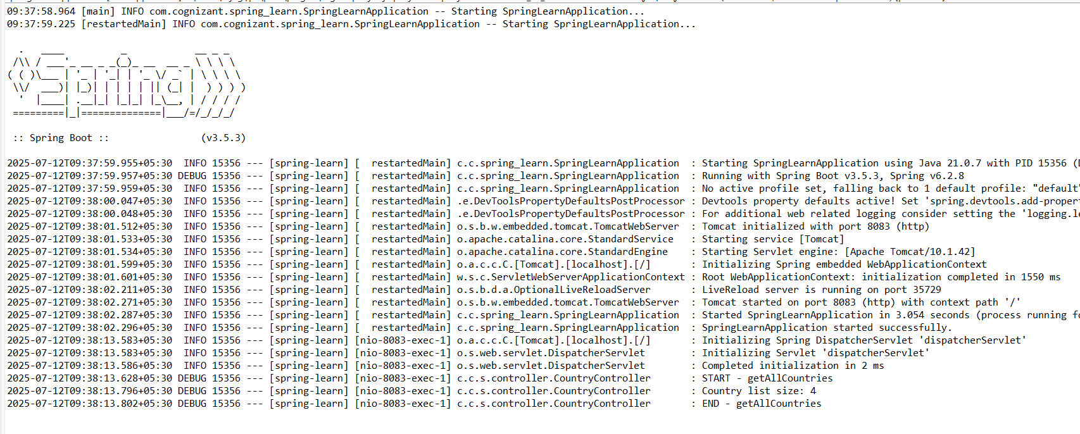

<http://localhost:8083/countries>

